“Count” , additional description ( to know total number of submitted PDC or approved ADA )
To add “ADA” (Auto Debit Advise) status

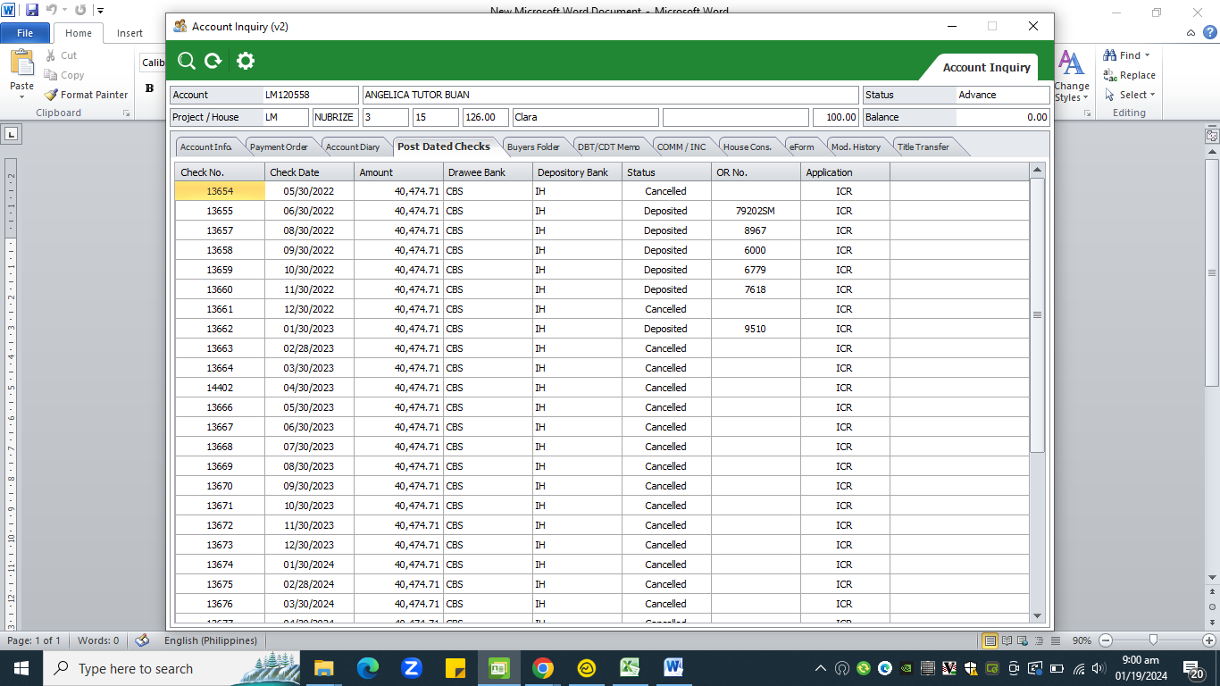
Count

